1 Open or create a project in Rstudio

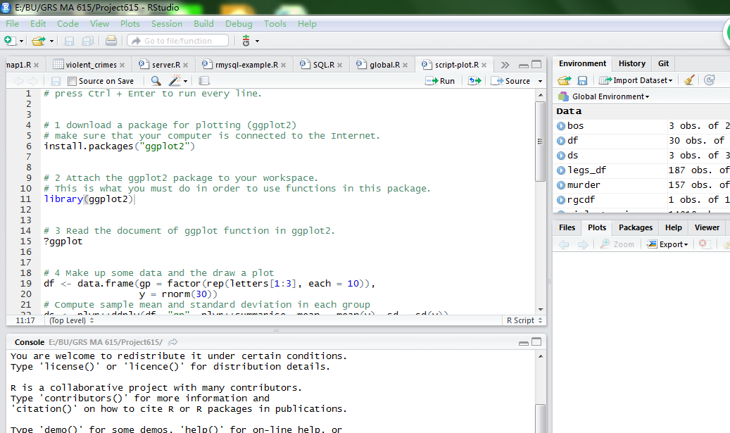

2 Click on Tools tab -> Version Control -> Project Setup…

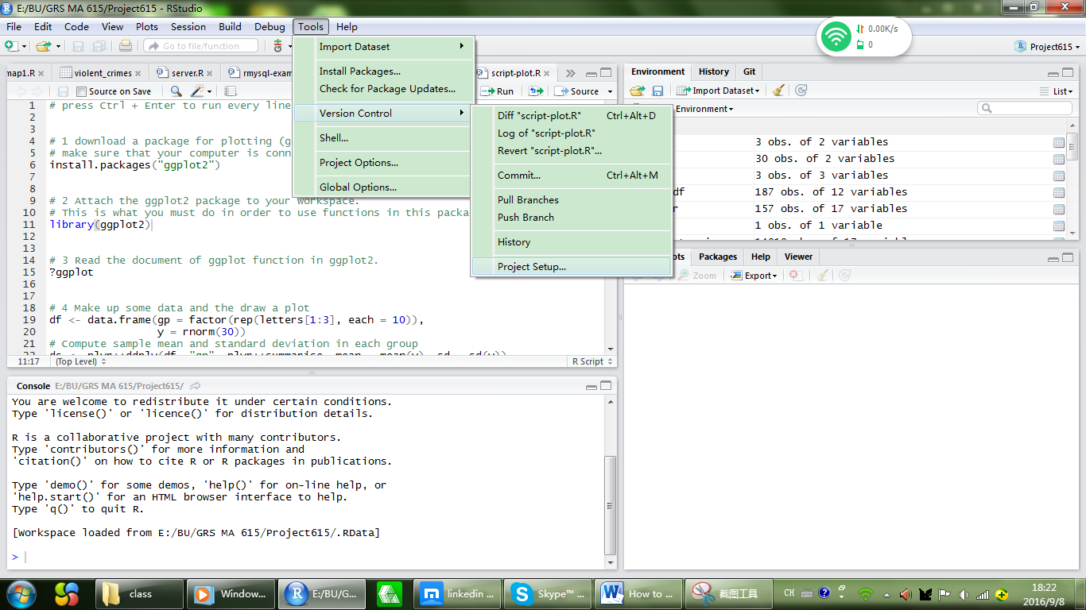

3 find the Git/SVN option and choose Git in the Version control system

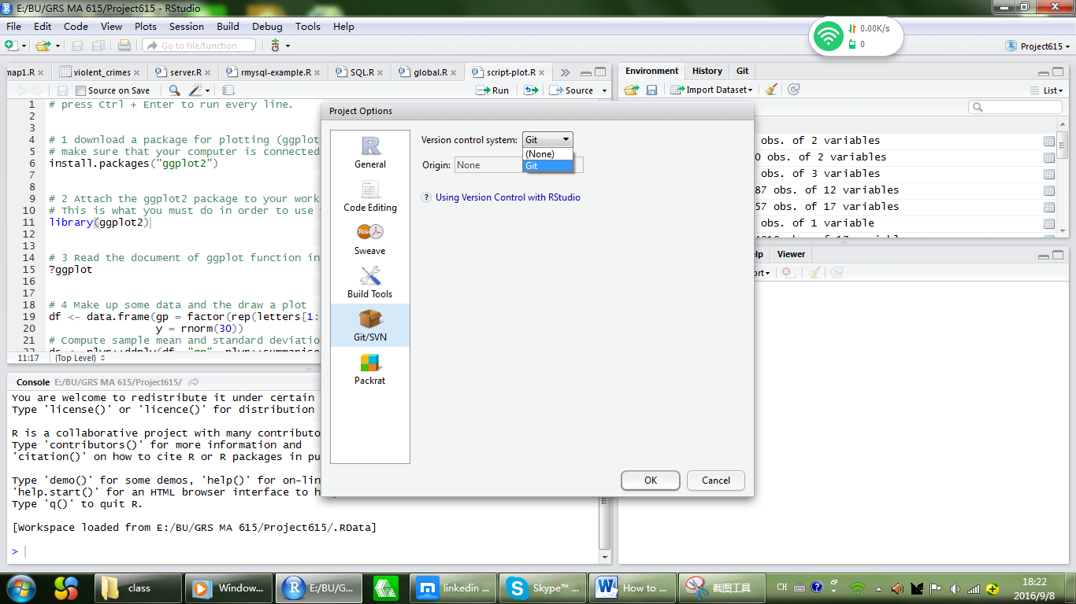

4 Click “OK”

5 After step 3 and 4, there will be a Git tab next to Environment and History tab on the top right of the interface. Then you can check scripts and files that you want to commit. Then, you click the “Commit” button. Status “A” means you have never committed this file before, and it has just been added to your Git repository.

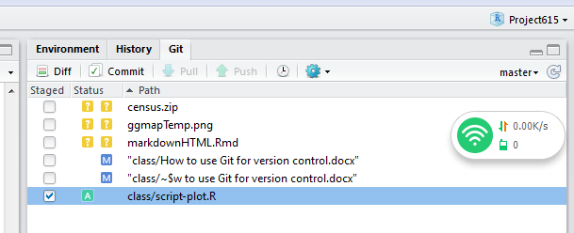

6 This is the window that pops out when you click on the commit button under Git tab. Note that you have to say something, like what are those files, why you did this, anything you want in the commit message. You cannot leave this place blank.

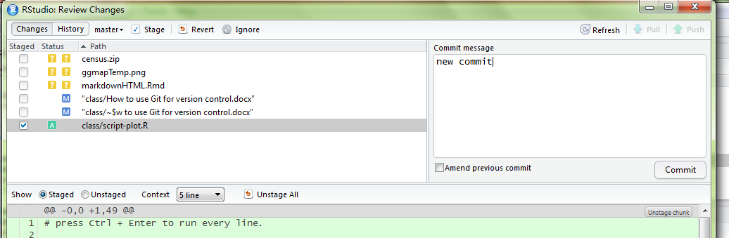

7 After you click the “Commit ” button in this window, you will see something like this, which means you have committed successfully.

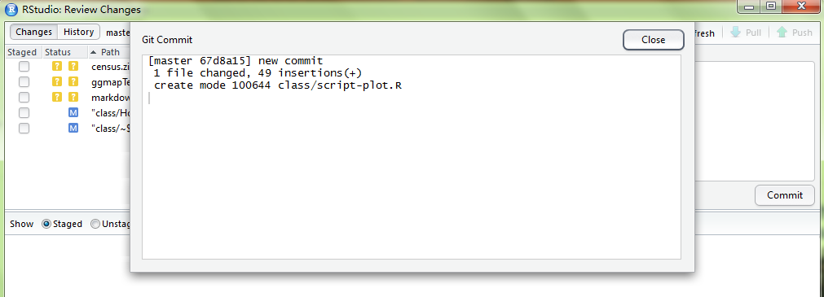

8 As soon as your files are committed, they will no longer show up under Git tab, unless you changed them.

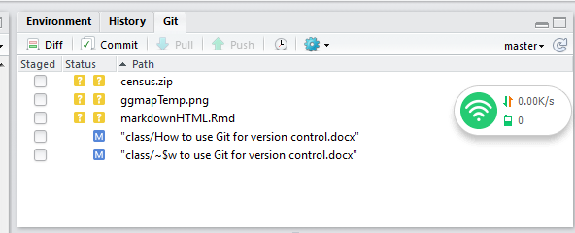

9 Now if I add a new line in the file script-plot.R, we could see it again. The status “M” indicates that you had committed this file before and now you changed it.

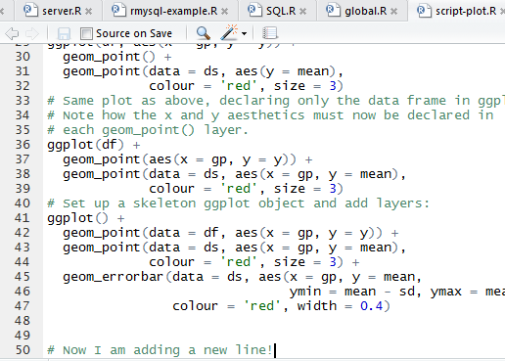

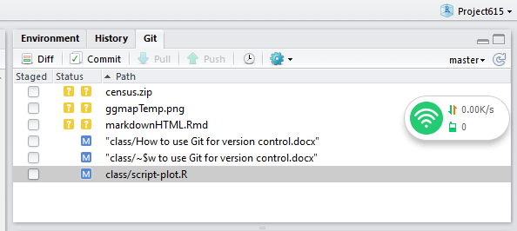

10 Now we want to put the repository onto GitHub. First, go to Tools -> Global Options(!!not project options!!) -> Git/SVN

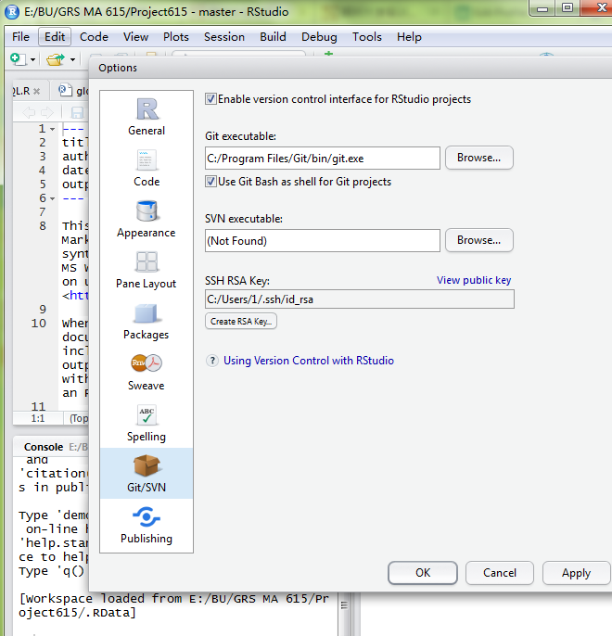

11. Click the **Create RSA Key** under the SSH RSA Key, you don’t need to put anything in Passphrase. Then click **View public key.** Press Ctrl + C to copy that.

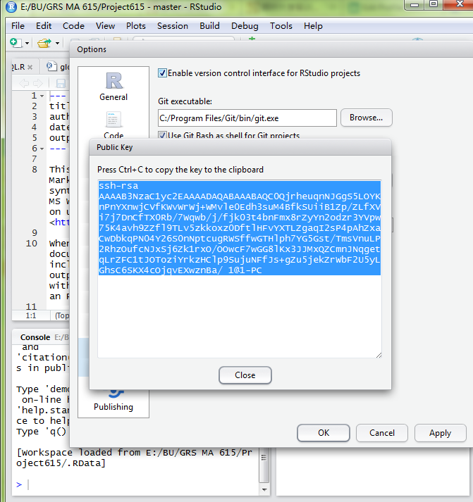

12 Now, if you haven’t created GitHub account, go create one. If you’ve already had one, go to your Github account’s Settings -> SSH and GPG keys. Press **New SSH key** and paste the key into it, name the title, and add SSH key.

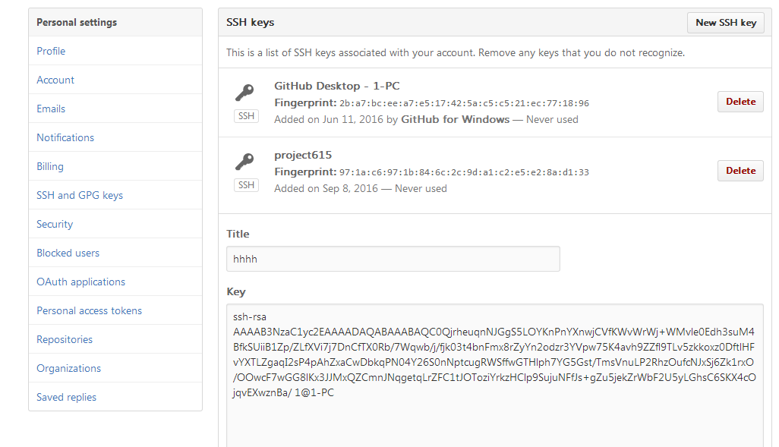

13 Then, create a new repository:

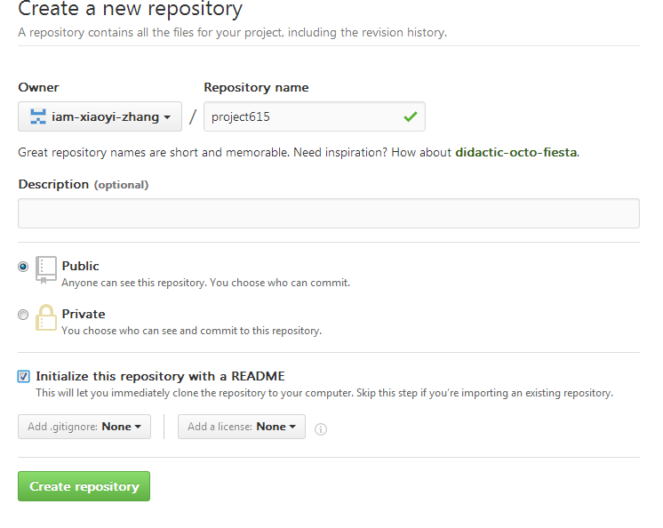

14 Now, in Git bash under the project’s directory, we want to push our repository:

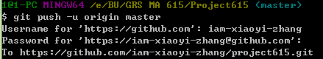

15 Oops! It’s rejected, why is that? That’s because we created a Readme file in the GitHub repository and if the local repository does not have every file in the online repository with the same name, then we cannot push it before we pulled (download) it.

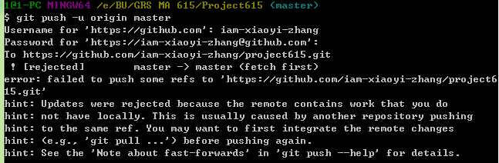

16 So we pull the repository on github. Remind that, git pull command will not only automatically copy and paste every file on GitHub repository to your local repository but also keep all your new local works safe at the same time.

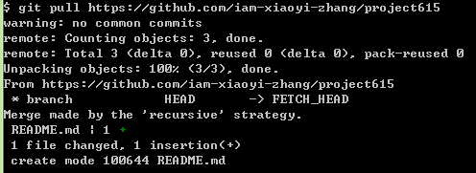

17 Now we can push our works! My username is iam-xiaoyi-zhang, you should use your own name.

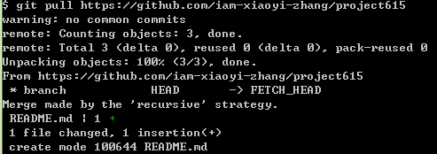

18 Now, open my GitHub and I can see every file I committed!

